Evan Carnevale

Professor Albluwi

CSC 110 – Survey of Computer Science

January 31st, 2016

Homework 1 – Introduction

1)

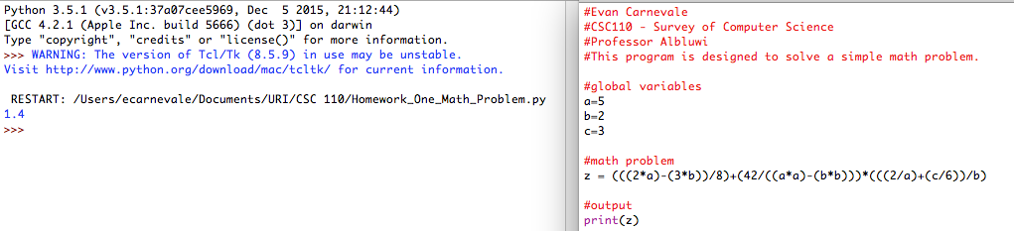

2)

